ShopNest Store Power BI Capstone detailed report document

- Question Statement:
Top categories by Total price
Identify and visually represent the top 10 product categories by total sales.
Visualization:
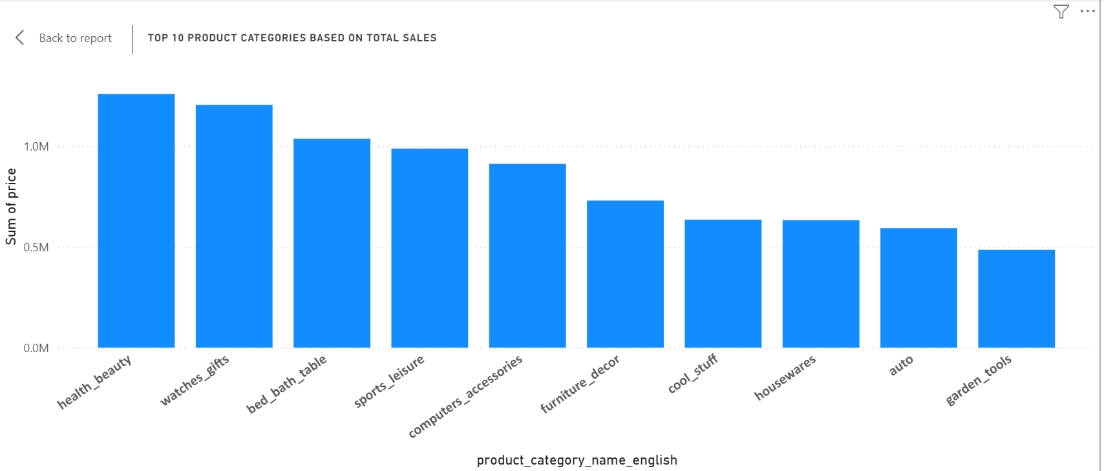
Explanation:
The bar chart visualizes the top 10 product categories based on total sales. The Y-axis represents the sum of price(total sales), while the x-axis lists the product categories.
Key Insights:
- Health_beauty, watches_gifts and bed_bath_table stands in top 1, 2 and 3 positions respectively, all exceeding 1M in total sales
- Categories such as sports_leisure and computer_accessories lands under Mid_Tier Categories showing strong but slightly lower sales.
- Housewares,auto and garden_tools are the lowest within top 10, indicating lower sales compared to the leading categories.
Findings:
- Dominance of health and beauty products suggests high consumer demand in this category.
- Watches and gifts being a top category might indicate a strong market for luxury based purchases.
- Presence of home-related categories (e.g., bed_bath_table, furniture_decor) suggests significant spending on household items.
- Auto and garden_tools categories, while still in top 10, have lower sales, which could indicate a more specialized market.

- Question Statement:
Delayed orders Analysis
Determine the number of delayed orders in each category. An order is considered delayed if the actual delivery date is later than the estimated delivery date.
Visualization:
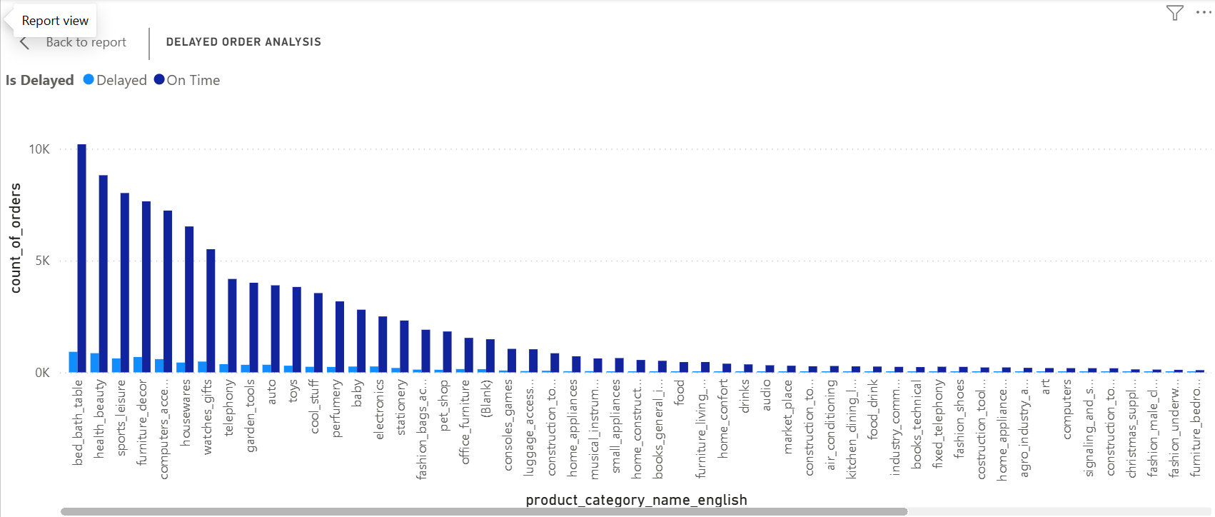
Explanation:
The bar chart presents an analysis of delayed orders across different product categories. The Y-axis represents the count of orders, while the X-axis lists various product categories. The chart differentiates between delayed (light blue) and on-time (dark blue) orders.
Key Insights:
- Bed_bath_table, health_beauty, and sports_leisure categories have the highest number of orders, where maximum of the orders are delivered on time.
- Mid-Tier Categories such as furniture_decor, housewares, watched_gifts and computers_accessories also have shown a substantial volume of orders, with a noticeable portion being delayed.
- Product categories towards the right, such as luggage_access, console_games, and industrial items, have significantly fewer orders and minimal delays.
Findings:
- The top categories affected by delayes are those realted to home goods, beauty and leisure products.

- Question Statement:
Monthly comparison of Delayed and On-Time Orders
Create a dynamic visual that compares the number of delayed orders to the number of orders received earlier for each month.
Visualization:
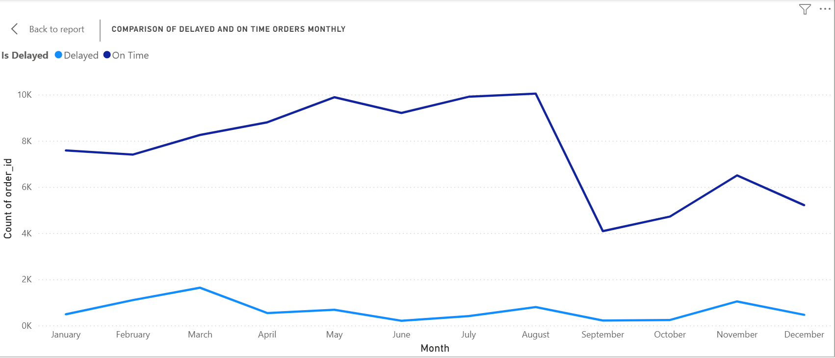
Explanation:
The line chart compares delayed (light blue line) versus on-time (dark blue line) orders across each month, with Y-axis showing the count of orders and the X-ais showing the months from January to December.
Key Insights:
- The On-time delivered orders line sits above the delayed delivered order line, indicating a consistently higher volume of on-time delivered orders throughout most of the year.
- Delayed orders reached their highest point in first quarter which is in March.
- On-time delivered orders reached their highest point in August and have immediately dropped down to the lowest peak in September.
Findings:
- The surge in delayed orders during March could point to increased demand or logistic issues that outpace the capacity.
- The late year spike in delays may align with holiday shopping or year-end sales.

- Question Statement:
Payment Method Analysis
Analyse the most frequently used payment method by customers.
Visualization:
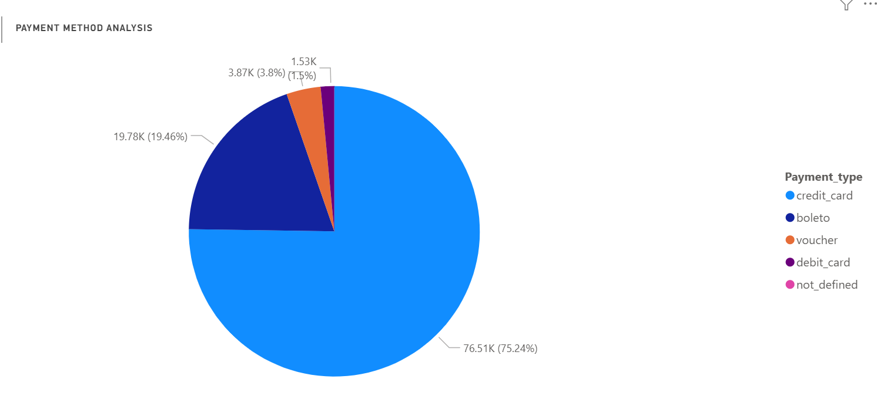
Explanation:
The pie chart illustrates the distribution of payment methods used. Each slice represents a different method of payment – credit card, boleto, voucher, debit card, and not defined along with the percentage of total transactions.
Key Insights & Findings:
- Evidently credit card accounts for the largest share (around 75%), indicating that most of the customers rely on credit crad transactions.
- Second largest share is for boleto which makes up roughly 20% of transactions.
- Voucher usage is modest (around 4%) and debit card goes with second smallest segment (around 1-2%) where the first smallest segment is not defined, suggesting incomplete or missing payment data.

- Question Statement:
Product Rating Analysis
Determine the Top 10 highest-rated products and the bottom 10 lowest-rated products.
5.1 Top 10 highest-rated products
Visualization:
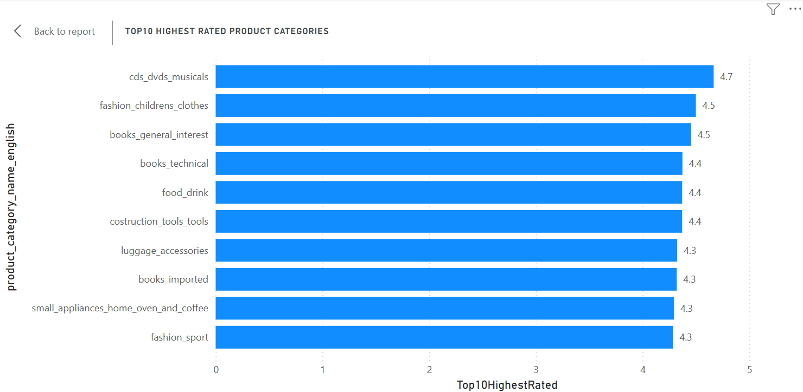
Explanation:
The bar chart displayed in the Power BI dashboard visualizes the Top 10 Highest Rated Product Categories based on customer ratings.
Key Insights:
- Cds_dvds_musicals has the highest average rating of 4.7, indicating strong customer satisfaction in this entertainment segment.
- Three book-related categories, books_general_intrest with average rating of 4.5, books_technical with average rating of 4.4 and books_imported with average rating of 4.3 are among the top-rated, showing that customers highly value books across different genres.
- Children’s fashion is highly rated with 4.5 of average rating, where food_drink is rated 4.4, showing that consumable goods are well received by costomers.
- Luggage_accessories, fashion_sport and small_appliances_home_oven_and_coffee have an average rating of 4.3 which indicates positive customer experiences with these functional products.
Findings:
- Entertainment which includes CDs/DVDs and books perform exceptionally well, indicating a strong customer intrest in media and literature.
- Fashion, food, tools and home appliances have good ratings, which may indicate a demand for quality and reliability in these categories.

5.2 Bottom 10 lowest-rated products
Visualization:
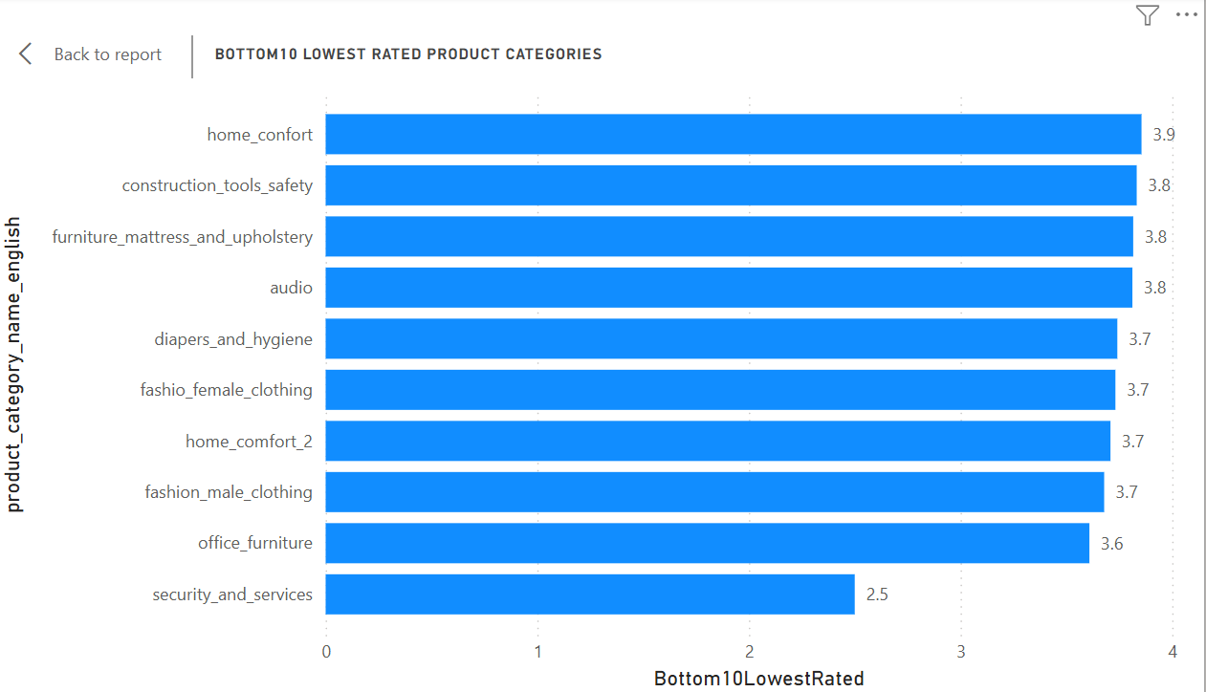
Explanation:
The bar chart visualizes the Bottom 10 Lowest Rated Product Categories based on customer ratings with product categories on the Y-axis where X-axis having the rating score.

Key Insights:
- Security_and_services has the lowest rating of 2.5, significantly lower than all other categories, indicating major customer dissatisfaction in this area.
- Categories like home_comfort (3.9), furniture_mattress_and_upholstery (3.8), home_comfort_2 (3.7) appear in bottowm 10, suggesting customers are unhappy with product quality, pricing or service in the home goods sector.
- Construction_tools_safety has a rating of 3.8, implying possible concerns about durability, effectiveness, or pricing of safety-related products.
- Both fashion_female_clothing and fashion_male_clothing have ratings of 3.7, indicating potential dissatisfaction with quality, fit, or variety in these clothing categories.
- Office_furniture with 3.6 rating and audio with 3.8 rating are among the lower-rated categories, suggesting that customers may have concerns about design, durability, or performance.
- Given that hygiene products are essential, a 3.7 rating might indicare issues with quality, effectiveness, or price competitiveness.
Findings:
- Security and services require urgent attention, as it has the lowest rating (2.5), possibly due to poor customer experiences.
- Home related and furniture categories need improvement, as multipe products in this segment are among the lowest-rated.
- Fashion, office furniture, and safety tools may need better quality control and product enhancements to improve customer satisfaction.
- Question Statement:
State-wise sales Analysis
Identify and visually represent states with high and low sales, providing a clear understanding of regional sales performance.
Visualization:
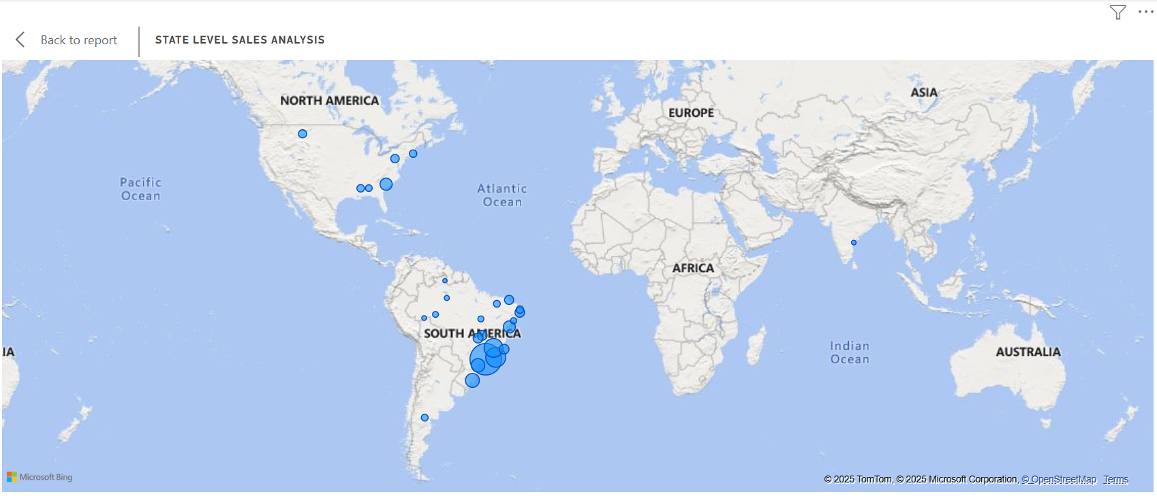
Explanation:
The visualization represents State-Level Sales Analysis using a geographic map. The blue bubbles indicate the sales distribution across different regions, with their size likelt representing the magnitude of sales.
Key Insights:
- The highest density of sales activity is seen in Brazil and surrounding regions, with State SP having the highest sales of 5.2M.
- There are noticeable sales points in the United States and Mexico, though they appear less concentrated compared to South America.
- Few or significant sales points are visible in Europe and Asia, indicating either low market penetration or lack os sales activity in these regions.
- No recorded sales in Africa and Australia.
Findings:
- Strong presence in South America indicates a key market opportunity where businesses can further expand and optimize operations.
- North America has moderate sales activity, suggesting potential for growth with targeted marketing and expansion efforts.
- Limited or no presence in Europe, Asia, and Africa indicates untapped markets that could be explored for global expansion.
- Question Statement:
Seasonal Sales Patterns
Investigate and visualize any seasonal patterns (Quarterly) or trends in sales data over the course of the year.
Visualization:
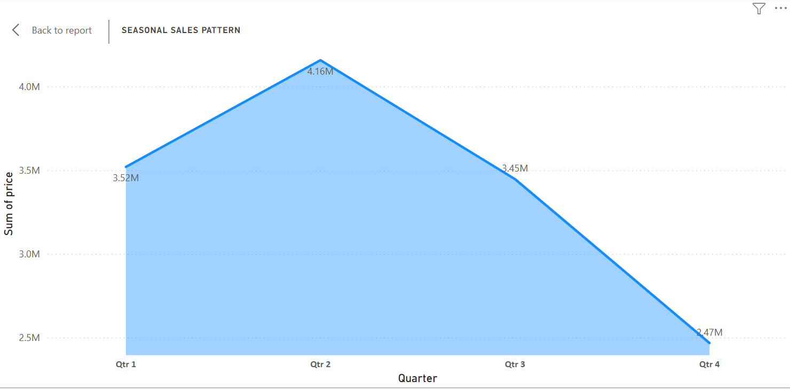
Explanation:
The visual dispalyed in an area chart representing the seasonal sales pattern based on the sum of price across four quarters (Q1 to Q4).
Key Insights:
- Sales start at 3.52M in Quarter 1
- They peak in second quarter at 4.16M, indicating the highest sales period.
- Sales then decline in Quarter 3 to 3.45M and further drop in Quarter 4 to 2.47M.
Findings:
- The highest sales occur in second quarter, suggesting that this period may be influenced by factors such as seasonal demand, promotions, or holidays.
- Significant drop in fourth quarter could indicate lower demand, seasonal slowdowns, or other external factors.
- Question Statement:
Revenue Analysis
Determine the total revenue generated by Shop Nest Store and analyse how it changes over time(Yearly).
Visualization:
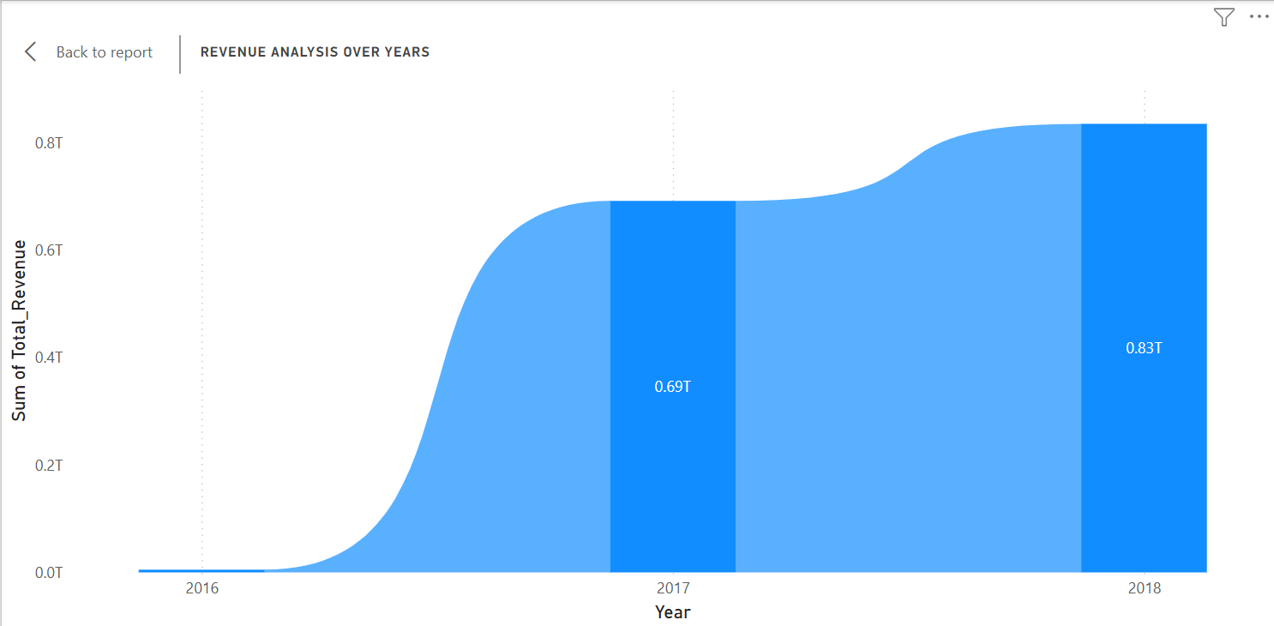
Explanation:
The visual shown in an area chart representing revenue analysis over the years from 2016 to 2018.
Key Insights:
- The revenue starts at zero in 2016 and begins to rise sharply.
- By 2017, total revenue reaches t0 0.69T, showing significant growth.
- In 2018, revenue further increases to 0.83T, indicating continued expansion.
Findings:
- The steep rise in revenue from 2016 to 2017 suggests rapid business growth, possibly due to new product launches, market expansion, or increased sales efforts.
- Growth from 2017 to 2018 is more gradual, indicating a potential slowdown in revenue acceleration.
- Strong intial growth suggests a successful entry or expansion phase.
- Slower increase in 2018 could indicate market saturation, increased competition, or operational challenges.

